**Lab report no 1**



# Spring 2022

# CSE303L Data Communication Network

Submitted by: **Muhammad Ali**

Registration No: - 19pwcse1801

Class Section: A

Submitted to:

# Engr.**Faizullah**

Date: Friday 22, 2022

Department of Computer Systems Engineering

University of Engineering and Technology, Peshawar

**CSE 303L: Data Communication and Computer Networks**

**Credit Hours: 1**

**Contact Hours: 3**

**LAB ASSESSMENT RUBRIC**

|  |  |  |  |  |
| --- | --- | --- | --- | --- |
| **Demonstration of Concepts** | **Poor (Does not meet expectation**  **(1))**    The student failed to demonstrate a clear understanding of the assignment concepts | **Fair (Meet**  **Expectation (2-**  **3))**    The student demonstrated a clear understanding of some of the assignment concepts | **Good (Exceeds**  **Expectation (4-**  **5)**    The student demonstrated a clear understanding of the assignment concepts | **Score**      **30%** |
| **Accuracy** | The student misconfigured enough network settings that the lab computer couldn't function properly on the network | The student configured enough network settings that the lab computer partially functioned on  the network | The student configured the network settings that the lab computer fully functioned on the network |  |
| **30%** |
| **Following Directions** | The student clearly failed to follow the verbal and written instructions to successfully complete the lab | The student failed to follow the some of the verbal and written instructions to successfully complete all requirements of the lab | The student followed the verbal and written instructions to successfully complete requirements of the lab |
| **20%** |
| **Time**  **Utilization** | The student failed to complete even part of the lab in the allotted amount of time | The student failed to complete the entire lab in the allotted amount of time | The student completed the lab in its entirety in the al |  |
| **20%** |

**Lab 01**

**PC Network TCP/IP Configuration**

**OBJECTIVES OF THE LAB**

Following topics will be covered in this lab

* Gather information including connection, host name, Layer 2 MAC address and Layer 3 TCP/IP network address information.
* Compare network information to other PCs on the network.
* Identify tool used for discovering a computer’s network configuration.

**ABOUT IPCONFIG**

**ipconfig (Internet Protocol Configuration)** in Microsoft Windows is a console application. It can be used from MS-DOS shell to display the network settings currently assigned and given by a network. This command can be utilized to verify a network connection as well as to verify network settings. **Usage**

**ipconfig** [/allcompartments] [ /? | /all | /renew [adapter] | release [adapter] |/flushdns | /displaydns /registerdns | /showclassid adapter | /setclassid adapter [classidtoset] ] **Option Description**

================================================

|  |  |  |
| --- | --- | --- |
| **/?** |  | Display help message |
| **/all** |  | Display full configuration information |
| **/allcompartments** |  | Display information for all compartments |
| **/release** |  | Release the IP address for the specified adapter |
| **/renew** |  | Renew the IP address for the specified adapter |
| **/flushdns** |  | Removes the DNS Resolver cache |
| **/registerdns** |  | Refreshes all DHCP leases and re-registers DNS name |
| **/displaydns** |  | Display the contents of the DNS Resolver Cache |

**/showclassid** Displays all the DHCP class IDs allowed for adapter

**/setclassid** Modifies the DHCP class ID

================================================

The default is to display only the IP address, subnet mask and default gateway for each adapter bound to TCP/IP.

**Gathering TCP/IP configuration information**

**Step 1**

Establish and verify connectivity to the Internet. This ensures the computer has an IP address.

## Step 2

Use the Start menu to open the Command Prompt, an MS-DOS-like window. Press Start >

Programs > Accessories > Command Prompt

OR

Start > Programs > Command Prompt.

OR

Press Start>Run Then type cmd.

The following figure shows the Command screen. Type ipconfig and press the Enter key. The spelling of ipconfig is critical while case is not. It is short for IP Configuration.

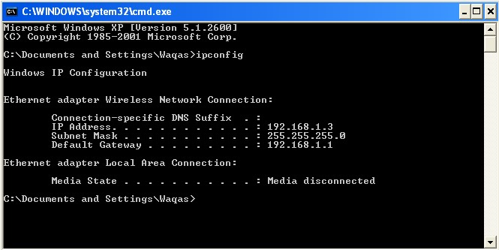

## Figure 1.1 Command Screen for ipconfig

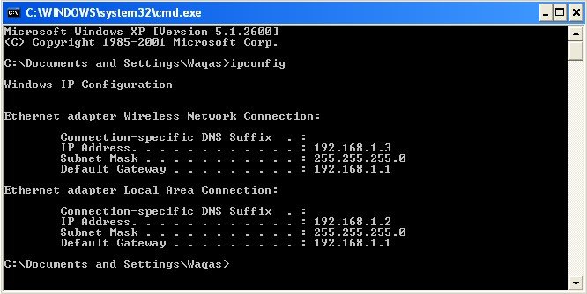

## Figure 1.2 Command Screen for ipconfig

This first screen shows the IP address, subnet mask, and default gateway. The IP address and the default gateway should be in the same network or subnet, otherwise this host would not be able to communicate outside the network. In the figure the subnet mask tells us that the first three octets must be the same to be in the same network.

Note: If this computer is on a LAN, the default gateway might not be seen if it is running behind a Proxy Server. Record the following information for this computer.

## Step 3

Record the following TCP/IP information for atleast THREE computers

|  |  |  |  |
| --- | --- | --- | --- |
|  | Computer 1 | Computer 2 (Neighbor 1) | Computer 3  (Neighbor 1) |
| IP Address | 192.168.137.247 | 192.168.137.254 | 192.168.137.48 |
| Subnet Mask | 255.255.255.0 | 255.255.255.0 | 255.255.255.0 |
| Default Gateway | 192.168.137.1 | 192.168.137.1 | 192.168.137.1 |
| DNS Address | 192.168.137.1 | 192.168.137.1 | 192.168.137.1 |
| DHCP Address | 192.168.137.1 | 192.168.137.1 | 192.168.137.1 |

Difference between Fig.1 and Fig.2: ________________________________________

## Step 4

Compare the TCP/IP configuration of this computer to others on the LAN

If this computer is on a LAN, compare the information of several machines.

Are there any similarities? **Yes subnet mask, default gateway, DNS address and DHCP address are same. _________________________________**

What is similar about the IP addresses? __________________________________________

What is similar about the default gateways? **default gateway are same on the LAN.** _________________________________

The IP addresses should share the same network portion. All machines in the LAN should share the same default gateway.

Record a couple of the IP Addresses:

**Step 5**

Check additional TCP/IP configuration information

To see detailed information, type ipconfig /all and press Enter. The figure shows the detailed IP configuration screen.

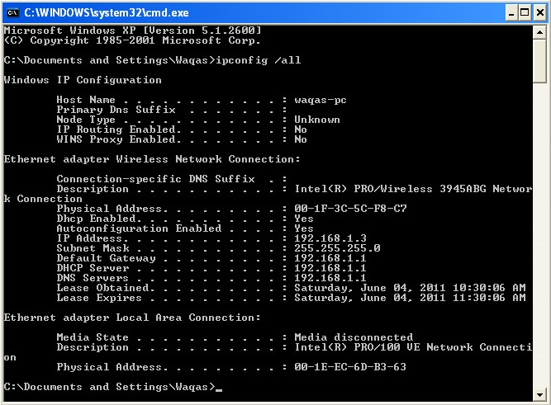

## Figure1.3 Command Screen for ipconfig /all

The host name, including the computer name and NetBIOS name should be displayed. Also, the

DHCP server address, if used, and the date the IP lease starts and ends should be displayed. Look over the information. Entries for the DNS, used in name resolution servers, may also be present.

The previous figure reveals that the router is performing both DHCP and DNS services for this network. This would likely be a small office or home office (SOHO) or small branch office implementation.

Notice the Physical Address (MAC) and the NIC model (Description).

______ E4-A7-A0-35-64-B6_________________________________

Write down the IP addresses of any servers listed:

# 192.168.137.247(Preferred)

**Write down the computer Host Name:**

DESKTOP-I9MQBNU _________________________________________________________________________ **Write down the Host Names of a couple other computers:**

_____________Mohsin laptop____________________________________________

**Do all of the servers and workstations share the same network portion of the IP address as the student workstation**? _________YES___________

It would not be unusual for some or all of the servers and workstations to be in another network. It means that the computer default gateway is going to forward requests to the other network.

## Step 6

Close the screen when finished examining network settings.

Repeat the previous steps as necessary. Make sure that it is possible to return to and interpret this screen.

Based on observations, what can be deduced about the following results taken from three computers connected to one switch?

**Computer 1**

IP Address: 192.168.5.13

Subnet Mask: 255.255.255.0

Default Gateway: 192.168.12.1

**Computer 2**

IP Address: 192.168.5.5

# Subnet Mask: 255.255.255.0

# Default Gateway: 192.168.12.1

**Computer 3**

IP Address: 192.168.11.97

Subnet Mask: 255.255.255.0

Default Gateway: 192.168.12.1

Should they be able to talk to each other?

______________________________________________________________________________ Are they all on the same network? Why or why not?

They are on the same network because of their similar default gateway.

______________________________________________________________________________